**GLA UNIVERSITY**

**Project Synopsis:**



**TOPIC: MINI PROJECT SYNOPSIS ON RECIPE SHARING PLATFORM**

**Submitted To:**

Faculty Name: Mr. Akash Kumar Choudhary

Technical Trainer:

**Submitted By:**

Aftab Alam[221500]

Divanshu Agrawal[2215000626]

Kartikay Trivedi[2215000885]

Prakash Dixit[2215001256]

Pushpak Singhal [2215001366]

DECLARATION

We, the undersigned, hereby declare that we are a team committed to completing the project titled RECIPE SHARING PLATFORM. We confirm that the work will be done collaboratively by us, and we take full responsibility for its execution.

Team Members:

1. Name: Divanshu Agrawal  
   Class: 3AA  
   Roll No: 2215000626
2. Name: Kartikay Trivedi [  
   Class: 3AA  
   Roll No: 2215000885
3. Name: Aftab Alam  
   Class:3AA  
   Roll No: 221500
4. Name: Prakash Dixit  
   Class: 3AA  
   Roll No: 2215001256
5. Name: Pushpak Singhal  
   Class: 3D   
   Roll No: 2215001366

Mentor:

Name: ____________________  
Designation: ____________________  
Contact Information: ____________________

We affirm that the work presented will be original and produced by our team.

Date: ____________________

INDEX

This Index is a reference for synopsis only

.

|  |  |
| --- | --- |
| S.NO | Topic |
| 1 | Introduction |
| 2 | System Requirements |
| 3 | Hardware Requirements |
| 4 | Front End and Back End |
| 5 | DFD |
| 6 | Idea |
| 7 | References |

INTRODUCTION

Cooking is a universal activity that brings people together, yet many find it challenging to navigate the overwhelming amount of recipes available, manage meal planning, and discover new meal ideas based on what ingredients they have on hand. The digital landscape lacks a centralized platform that merges these needs, leaving users with scattered solutions that often detract from the joy of cooking. This project aims to fill that gap by offering a simple, yet comprehensive solution that combines recipe submission, ingredient-based meal ideas, user feedback, and meal planning. In doing so, it seeks to make cooking an enjoyable, creative, and community-driven experience.

The project will create an all-in-one platform that addresses the common frustrations faced by home cooks. It will allow users to easily share their recipes, receive feedback through ratings, and search for meal ideas based on the ingredients they already have. In addition, the platform will feature meal planning tools, complete with shopping lists and nutritional information. By bringing together these essential features, the platform will enhance the overall cooking experience, making it more accessible, efficient, and enjoyable for users of all skill levels.

About the project

The project is designed to streamline and enhance the cooking experience by offering a user-friendly platform that integrates recipe submission, smart ingredient search, and meal planning. Users can upload their recipes, share them with a community of like-minded cooking enthusiasts, and receive ratings that reflect the quality and appeal of their dishes. The platform's smart ingredient search function will allow users to input ingredients they already have, generating meal suggestions to reduce food waste and inspire creativity in the kitchen.

Additionally, the platform will include meal planning features that help users organize their meals in advance, complete with auto-generated shopping lists and nutritional information for each recipe. By creating a collaborative environment where users can share tips, follow one another, and engage in meaningful conversations about cooking, this platform fosters a sense of community and shared learning. Ultimately, the project seeks to bring convenience, inspiration, and social connection to the cooking process

**Primary Reason to Choose This Project**

Choosing this topic stems from the growing interest in home cooking and the increasing demand for convenient, accessible resources that enhance the culinary experience. As more people seek to explore their cooking skills and embrace healthier eating habits, a platform that combines recipe sharing, user ratings, ingredient search, and meal planning can significantly simplify the process.

With the rise of social media and food blogging, individuals are more inspired than ever to try new recipes and share their culinary adventures. However, they often encounter barriers such as sifting through countless sources for reliable recipes or struggling to make meals with what they have on hand. A centralized platform can address these challenges, providing a streamlined experience that encourages exploration and creativity in the kitchen.

This topic also resonates with the current trend of personalized cooking experiences, allowing users to tailor their meals based on available ingredients and dietary preferences. The ability to plan meals effectively can lead to better nutrition, reduced food waste, and more mindful consumption.

Furthermore, fostering a community around cooking can inspire collaboration and creativity, making it a more enjoyable and social activity. By incorporating features that enable users to connect, share tips, and offer support, we can create a vibrant environment that celebrates culinary diversity.

In summary, this topic not only meets the practical needs of users but also taps into the emotional aspects of cooking, such as connection, creativity, and personal growth. By addressing these needs, we can contribute to a culture of cooking that empowers individuals, promotes healthier lifestyles, and strengthens connections within the culinary community.

**The Main Objective of the Project**

The main objective of this project is to create a comprehensive, user-friendly platform that enhances the home cooking experience by integrating multiple essential features into a single, cohesive system. Specifically, the platform aims to:

1. **Streamline Recipe Sharing**:
   * Enable users to easily upload and share their recipes with a community of cooking enthusiasts.
   * Provide a rating and feedback system to help users gauge the quality and appeal of their recipes.
2. **Facilitate Smart Ingredient-Based Search**:
   * Allow users to input the ingredients they have on hand to generate meal suggestions, reducing food waste and inspiring culinary creativity.
3. **Simplify Meal Planning**:
   * Offer tools for users to organize and plan their meals in advance, including auto-generated shopping lists and nutritional information for each recipe.
4. **Foster a Collaborative Cooking Community**:
   * Create a social environment where users can follow each other, share tips, and engage in meaningful conversations about cooking.
   * Encourage collaboration and the exchange of culinary ideas and experiences.
5. **Enhance Accessibility and Convenience**:
   * Design an intuitive and user-friendly interface that makes cooking more accessible and enjoyable for users of all skill levels.
   * Provide personalized cooking experiences by allowing users to tailor their meals based on available ingredients and dietary preferences.

By achieving these objectives, the platform seeks to make cooking a more enjoyable, efficient, and community-driven activity, ultimately promoting healthier eating habits, reducing food waste, and fostering a culture of culinary exploration and connection

**Scope Of the Project**

The future of a recipe sharing platform looks bright, and here are some simple ideas on how it can grow:

1. **Personalized Suggestions**: The platform can recommend recipes based on what users like to eat, their cooking skills.
2. **Social Features**: Users could share their cooking stories, and join cooking challenges to connect with others.
3. **Video Content**: Adding cooking videos can make the platform more fun. Teaming up with popular chefs can also attract more users.
4. **Focus on Sustainability**: Featuring recipes that use local, seasonal, and plant-based ingredients can appeal to environmentally conscious users.
5. **Health and Nutrition**: Including nutritional information and healthy recipes can attract health-focused users.
6. **Ways to Make Money**: The platform can offer subscriptions, premium content, or partner with grocery delivery services for revenue.
7. **Reaching Global Audiences**: Localizing recipes for different cultures can bring in //more users and encourage diverse cooking.
8. **User-Generated Content**: Allowing users to share their own recipes can keep the platform fresh and create a strong community

**Working Methodology of the Project**

1. Research Design:
   * Use a user-centered design approach to ensure the platform meets the needs of home cooks and food enthusiasts.
2. Data Collection:
   * Conduct surveys and interviews with potential users to understand their preferences for features and usability.
   * Analyze existing recipe sharing platforms to identify key functionalities and user pain points.
3. Prototyping:
   * Create wireframes and mockups using design tools (e.g., Figma, Adobe XD) to visualize the user interface and layout.
   * Develop an interactive prototype to gather initial feedback from potential users.
4. Development Process:
   * Follow an Agile methodology with iterative sprints, allowing for continuous feedback and adjustments.
   * Core features to develop include:
     + User registration and authentication via Firebase.
     + Recipe creation and uploading functionality.
     + Recipe browsing and search filters for easy navigation.
     + Commenting and rating system for community engagement.
5. Testing:
   * Conduct unit tests for individual components and integration tests to ensure they work together as intended.
   * Perform user acceptance testing (UAT) with real users to validate the overall functionality and usability of the platform.
   * Use tools like Jest for testing React components.
6. Deployment:
   * Deploy the application using Firebase Hosting for seamless integration with Firebase services.
   * Utilize Git for version control and implement CI/CD practices for efficient updates and maintenance.
7. Feedback and Iteration:
   * Launch a beta version to gather user feedback and identify areas for improvement.
   * Iterate on the platform based on user insights, enhancing features and user experience.

**Summary of the Project**

The goal of this project is to create a user-friendly recipe sharing platform that allows home cooks to share, discover, and save recipes. By leveraging Firebase for secure authentication and real-time database capabilities, along with React for a dynamic user interface, the platform will include features like user profiles, recipe uploads, browsing, and community engagement through comments and ratings.

Through thorough user research, prototyping, and an Agile development approach, we aim to deliver a robust web application that fosters a vibrant community of food enthusiasts, encouraging cooking, sharing, and exploring diverse culinary experience

**Details About the Hardware and the Software**

**System Requirements**

Supported Operating Systems:

* Windows: Windows 10 (Version 1809 or later), Windows 11 (all versions)
* macOS: macOS Catalina (10.15) or later
* Linux: Ubuntu 20.04 LTS, Debian 11
* Mobile: Android 8.0 (Oreo) or later, iOS 13 or later

Software Required:

**Listing Out Testing Technologies**

Based on the project plan, the following testing technologies are mentioned:

* Jest: For testing React components.

Additionally, the following testing types are mentioned:

* Unit tests: For individual components.
* Integration tests: To ensure components work together as intended.
* User Acceptance Testing (UAT): To validate the overall functionality and usability of the platform with real users.

Note that other testing technologies might be used in addition to Jest, but they are not explicitly mentioned in the project plan.

**Frontend**

* HTML/JSX: Structure the web pages and create reusable components for recipes, user profiles, and navigation.
* CSS: Style the application for an attractive and responsive user interface, using frameworks like Bootstrap or Tailwind CSS.
* React: Utilize the React library to build a dynamic and interactive user experience, enabling efficient updates as users engage with the app.

**Backend**

Firebase:

* Authentication: Use Firebase Authentication for secure user login, sign-up, and account management.
* Database: Implement Firebase Firestore to store and retrieve recipe data, user profiles, and community interactions in real-time.

**Data Flow Diagrams**

A data flow diagram (DFD) illustrates how data is processed by a system in terms of inputs and outputs. As its name indicates its focus is on the flow of information, where data comes from, where it goes and how it gets stored.

.

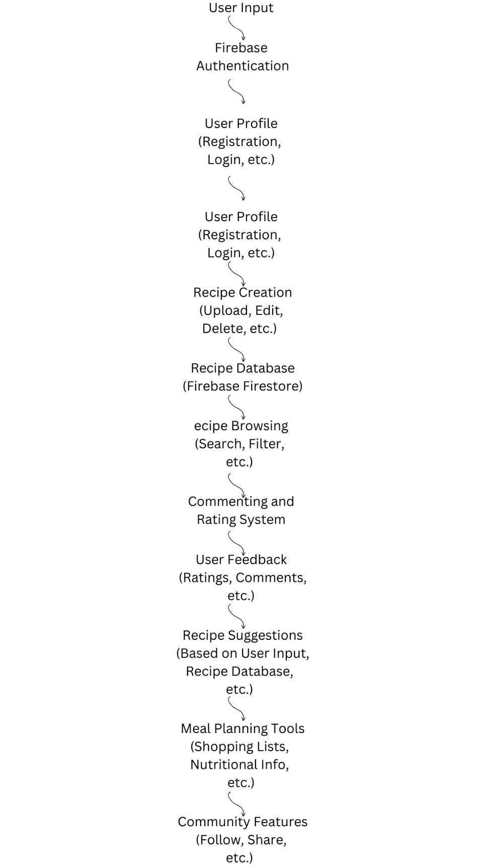



Idea

Introduction

The cooking platform we are developing aims to bridge the gap between recipe discovery, user engagement, and meal planning. Our users often struggle to find trustworthy recipes and organize meals based on available ingredients. With our platform, users will not only share their unique culinary creations but also receive feedback through ratings and comments. This dynamic interaction creates a space where cooking enthusiasts can exchange ideas and build a community around their shared passion for food. Our goal is to make cooking more enjoyable and accessible, while fostering creativity and reducing food waste.

Recipe Submission and Feedback

One of the platform's core features is the ability for users to submit their own recipes. This feature empowers home cooks to showcase their favorite meals while contributing to a rich database of culinary ideas. Users will receive feedback in the form of ratings and comments, encouraging constant improvement and refinement of their cooking skills. The platform promotes transparency by allowing everyone to view user-generated content, helping to build trust within the community as users can rely on peer reviews to determine which recipes best suit their tastes and preferences.

Smart Ingredient Search and Waste Reduction

To address the common problem of wasted ingredients, our platform will incorporate a smart ingredient search feature. Users can input ingredients they already have at home, and the system will suggest recipes that make use of those items, helping to minimize waste. This feature encourages resourceful cooking and ensures that users can make the most of what they already have in their kitchens. By offering creative solutions for meal planning based on available ingredients, we aim to make cooking both practical and fun, promoting sustainable habits.

Meal Planning and Social Connectivity

In addition to recipe discovery, our platform offers users a comprehensive meal planning tool. This feature allows users to create personalized meal plans complete with shopping lists and nutritional information, making it easier to manage weekly meals. Furthermore, the platform will include social connectivity options like user profiles, comment sections, and the ability to follow other users. These social features encourage collaboration, enabling cooking enthusiasts to share tips, support one another, and engage in meaningful culinary projects. By building a supportive community, the platform fosters a more connected and interactive cooking experience.

References